Endangered Animal Habitat Project
Dear Families,
In the classroom, students have been learning about animals, their characteristics, habitats, and how people affect animals. We will reinforced these concepts at Turtle Back Zoo when we specifically explored different animal species and their current state (critically endangered, endangered, vulnerable, near threatened). We will be continuing our studying in the classroom, as well as learning about the different classification of animals.
Students will complete an endangered animal habitat research project to reinforce these concepts. This project should be completed at home. Students will complete the animal research papers attached to this cover letter, as well as a visual for their project. For the visual, students can create a diorama, poster, book, movie etc. (be creative). The visual should show the animal being studied, and details of the habitat it lives in. For this project, students should pick an endangered, vulnerable, or near threatened animal. Here is a website to help your child pick an animal. They can also use an idea from Turtle Back Zoo.
https://www.worldwildlife.org/species/directory?direction=desc&sort=extinction_status
My hopes for this project are to reinforce what is being studied in the classroom in a fun creative way. Students should see the relationship between animals, how people can affect animals and their habitats, and how animals adapt to different environments. Students will present their work to the class, so they should practice at home presenting their project.
Due: Friday, December 7th 2017 (12/7/18)
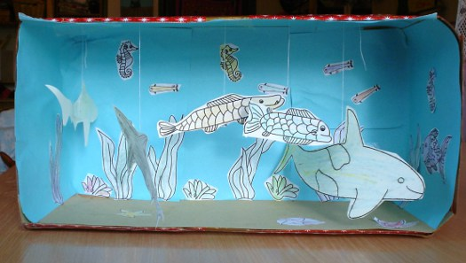
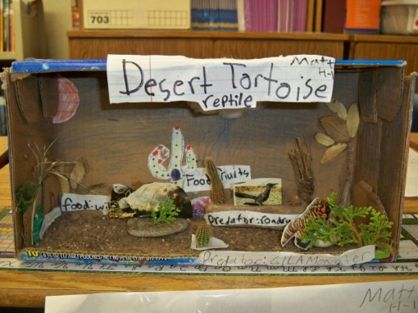
Examples:

Thank you,
Mrs. Vollmar

