Back to School Supply List
Hello new 2nd grade families! I hope you are enjoying your summer! Below is our 2nd grade supply list for items needed throughout the year. Most of the supplies gathered are communal items, so please do not put your child’s name on the items (other than the items listed under personal). Many of these items can be found at Target, Walmart, or Staples, and all locations run great back to school sales throughout the summer.
The Class Supplies are not needed from the whole class all at once since they are items we use throughout the year. If your last name is from A-G please bring in the class items the first week. (email reminders will be sent for all groups )
- H-N: please bring the items in at the beginning of the 2nd trimester
- O-Z: please bring the items in at the beginning of the 3rd trimester
*All Personal Items should be brought in by all students within the first week of school*
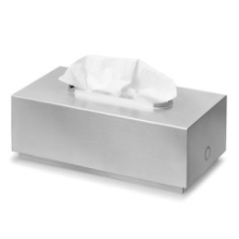
Class Supplies

- 2 boxes of tissues
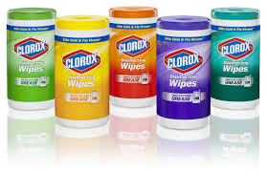
- 1 Clorox wipes
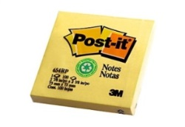
- 6 packets of 3x3 post-its

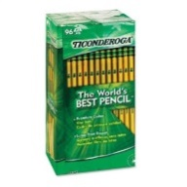
- 2 boxes of Ticonderoga pencils (sharpened is always better)
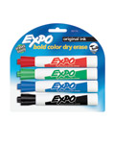
- 1 pack of dry erase markers

- 1 roll of paper towels

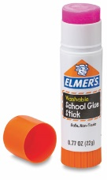
- 1 pack of glue sticks

Personal Supplies- All Personal items should be brought in the first week! (items that should have your child’s name)
- 1 wide ruled notebook (for homework)
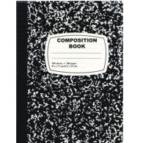
- 1 black composition notebook

- Headphones for in class use (put in a zip lock bag with your child’s name)

Thank you and enjoy the rest of your summer!

